IDEV102 Training

* Chapter 1: Itential AdapterPackages
  + Itential Adapters are node.js packages that integrate external systems with the Itential platform.
  + An adapter must have:
    - A package.json file
    - Pronghorn.json file
    - propertiesSchema.json file
    - configured from IAPs web UI
    - Adapters must be a Node.js module
    - Import the built in node.js events module, define class, and export the class.
    - A constructor method with two parameters(id string, properties object.
    - Connect() that performs an external system health check
    - OFFLINE event to signal external system not ready
    - ONLINE event to signal external system is ready
* Chapter 2: npm
  + Package.json file:
    - Describes the packages
    - Specifies version
    - Lists package dependencies
    - Specifies compatible package eversions
    - Makes the build reproducible
* Chapter 3: JSDoc
  + An API documentation generator for JavaScript.
  + Block tags begin with @
  + Inline tags denoted with {}
* Chapter 4: Node.js Callbacks
  + All public functions have a callback as the last parameter
  + IAP follows data, then callback syntax
  + Callbacks are executed in the sequence they are called, not in the sequence in which they are defined.
  + When a function has a callback parameter, it is stating that a function will be called there, not using callback as a variable.
  + To execute a function, you “call” it, which is why they are called callback functions.
  + Callbacks are used whenever we need to wait for something.
  + Callback is the last argument
  + Callbacks will always have two arguments. Node.js usually does error first, followed by data.
  + 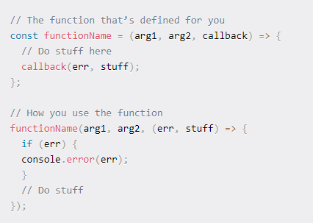
  + Parameters are used as variables within the function body
  + A callback function can be anonymous, not named.
  + Functional programming specifies the use of functions as arguments.
  + When a callback function is passed as an argument, the function definition is passed. The function is not being executed in the parameter.
  + A callback function is a closure.
  + The callback function is called as a parameter for use later in the function.
* Chapter 5: Node.js Labs
  + Refactoring is the process of restructuring existing code without changing its external behavior.
  + It can involve
    - Deduplicating code
    - Isolating logic by deconstructing code into intuitive functions offering a single place to review code
    - Makes code easier to read with good function
  + Benefits are:
    - Improves readability
    - Reduces complexity
    - Easier maintenance
    - Easier debugging
    - Reduces bugs
  + Modular programming
    - Improves maintainability
    - More easily identifies errors
    - Helps with variable scope
    - Less code needs to be written.
    - Code can be reused
    - Easier collaboration between programmers
* Lab 1:
  + Uses an npm package called ‘request’, which executes a REST API.
* Intermission: API video <https://www.youtube.com/watch?v=GZvSYJDk-us>
  + An interface is what is used to interact with the code behind the face.
  + REST – representational state transfer

**Chapter 6: IAP Adapter**

* IAP adapter objects emit events when the external service instance is tested.
* Uses the EventEmitter() function to call functions